Your Group Name
Our Fundraiser is nearing completion!
- Remember – Everyone that participates makes a difference!
- Our goal is to raise $XXX or for each student to sell just XXX items or more.
- You have XX days left before orders are to be turned in – keep selling!
Thank you for your Help!
(Coordinator’s Name Here)

Reminder

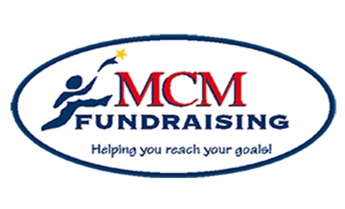

Details to Remember

Group Goal: $XXX
XX or more items
Incentive Program: sellxx to receivexx
Fundraiser Ends : (FR End Date)
(turn in forms)
Pick Up Date/Time: Month/Day at X:XX PM

MCM Fundraising, Inc.
672 Dart Hill Road, Vernon, CT 06066
Office: (888) 774-5889 860-375-8138
mcmteam@mcmfundraising.com
www.mcmfundraising.com

